Order Of Service

Singing: Psalm 72—CW page 93

Reading: Psalm 37:25-40

Opening Hymn: TLH 130

Reading: Revelation 21

Request Hymn: CW Supplement 749

Reading: John 9:1-12

Sermon Hymn: TLH 128

Sermon Text: Song Of Solomon 6:10

Morning Light

Prayer

The Apostles’ Creed, TLH page 12

Holy Communion

The Lord's Prayer

The Blessing

Closing Hymn: TLH 129

* * * * * * * * * * *

Bible Study: Lambs: Eagle
Sheep: Proverbs 14:21-25
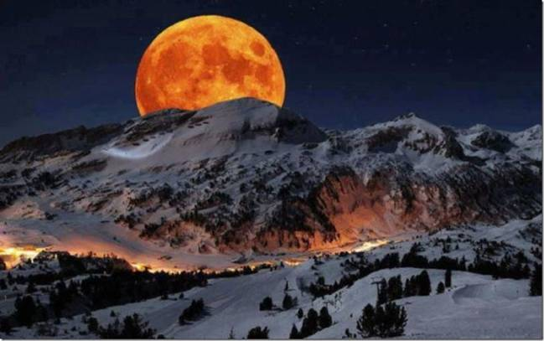

Morning Light

Water
Of
Life

14 May 2017

W A T E R O F L I F E

Independent Christian Church—Conservative Lutheran Doctrine

Worship Service: 9:30 a.m. Bible Study: 10:45 a.m.

Larry Cooper, Pastor E-Mail address:
111 N. Ridge Road lcooper@wateroflife.cc
Coon Valley, WI 54623 Web Site:
Phone: (608) 452-2105 www.wateroflife.cc

* * * * * * * * * * * * * * * * * * * * * * * * * * *

Sermon Text: Song Of Solomon 6:10

Morning Light

* * * * * * * * * * * * * * * * * * * * * * * * * * *

Song of Solomon 6:10 Who is she that looketh forth as the morning, fair as the moon, clear as the sun, and terrible as an army with banners?

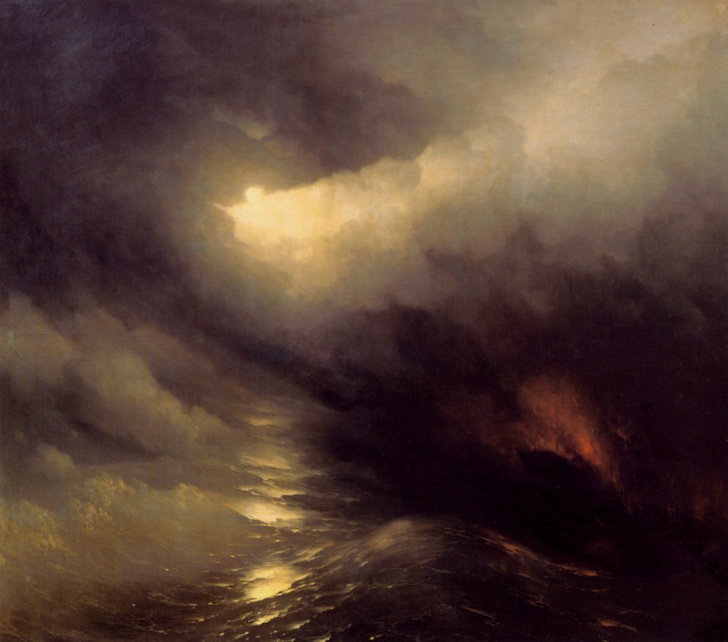
From the very beginning of creation we see a struggle between darkness and light.

Genesis 1:1 In the beginning God created the heaven and the earth.
:2 And the earth was without form, and void; and darkness was upon the face of the deep. And the Spirit of God moved upon the face of the waters.
:3 And God said, Let there be light: and there was light.
:4 And God saw the light, that it was good: and God divided the light from the darkness.
:5 And God called the light Day, and the darkness he called Night. And the evening and the morning were the first day.

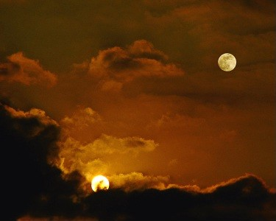

Then, on Day Four, the Holy Spirit tells us—

Genesis 1:16 And God made two great lights; the greater light to rule the day, and the lesser light to rule the night: he made the stars also. 17 And God set them in the firmament of the heaven to give light upon the earth, 18 And to rule over the day and over the night, and to divide the light from the darkness: and God saw that it was good.

Amazingly the Bride is compared to both!

